FOR IMMEDIATE RELEASE


Kahn & Selesnick
Mars: Adrift on the Hourglass Sea
January 6 – February 19, 2011
Gallery hours: Tuesday – Saturday, 10 – 6

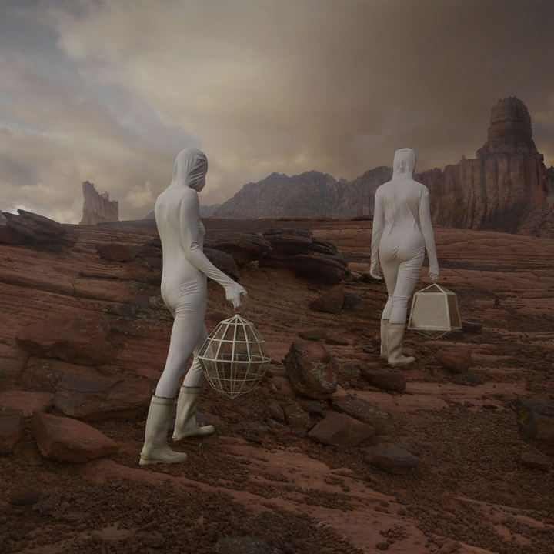
“Terror is in all cases the ruling principle of the sublime.”
Edmund Burke, 1756

Yancey Richardson Gallery is pleased to present Mars: Adrift on the Hourglass Sea, an exhibition of new photographs and sculpture by the collaborative team Kahn & Selesnick. In their fourth exhibition with the gallery, the artists present a dark and powerful visage of a collapsed civilization on the red planet. Integrating actual photo-mosaics of Martian landscapes taken by NASA space rovers, with their distinctive brand of sci-fi mysticism and art historical contexts, the artists offer a salient version of what constitutes the contemporary sublime landscape. The exhibition coincides with a show of the artist’s work at the Museum of Contemporary Photography, Chicago.

Recalling the visual sublimity of Casper David Friedrich and the existential wanderlust of Mary Shelley, Kahn & Selesnick weave together a narrative of human survival amidst the crumbling vestiges of a once inhabited landscape. The exhibition features two female protagonists and a child (whose birth on the rocky terrain is also documented), as they negotiate a path through a civilization’s ruins. A curious combination of stone-age monuments and high-tech devices litter the landscape – simultaneously ancient and futuristic – at turns resembling Stonehenge or the design of Buckminster Fuller, though largely devoid of visual clues that place the story within a recognizable time period.

Poignant issues of technology, economic and societal collapse, environmental disaster and existential philosophy are explored under the guise of a fantastical journey through the deserts of our neighbor planet. Additionally, the notion of Earth and Mars as planetary twins is advanced through repeated visual mirroring devices: the figure of Janus – two-faced god of portals – appears, as do the motifs of dividing cells and the recurrence of hematite rock clusters that appear, almost identically, on the surface of Mars and the deserts of Utah, a location used by Kahn & Selesnick for this project.

The artists Nicholas Kahn and Richard Selesnick have collaborated for more than twenty years on projects including Scotlandfuturebog, 2000; City of Salt, 2001; and Apollo Prophesies, 2004, all published in subsequent books by Aperture Press. The work of Kahn & Selesnick is held in the collections of the Los Angeles County Museum of Art, Brooklyn Museum of Art, Houston Museum of Fine Arts, Addison Gallery of American Art, Philadelphia Museum of Art, Fogg Museum of Art, and the National Portrait Gallery. In 2006, they were recipients of a NASA commission to create work about Mars, which was subsequently exhibited at the Smithsonian Museum of American Art.


For visuals, please contact Frank Goldman: fgoldman@yanceyrichardson.com

