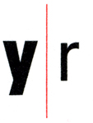
FOR IMMEDIATE RELEASE

Rachel Perry Welty: Lost in My Life
November 4 – December 23, 2010

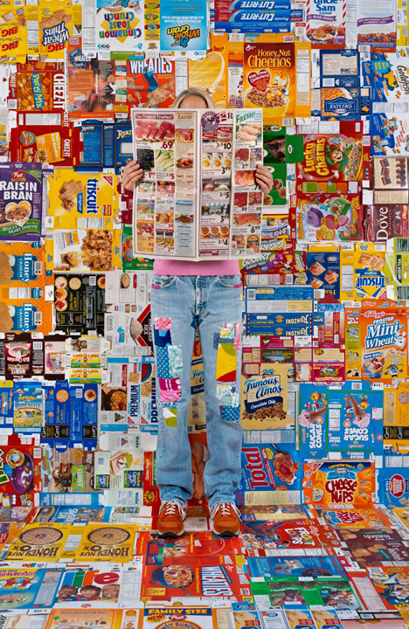
The Yancey Richardson Gallery is pleased to present Lost in My Life, an exhibition of photographs by Rachel Perry Welty. In her third solo exhibition with the gallery, Welty presents a series of photographs of herself subsumed by the discarded minutia of consumer culture. Part performance, part installation, Welty immerses herself in environments built entirely from familiar, leftover consumer materials: bread tags, price stickers, aluminum foil, twist ties, cardboard boxes, and Styrofoam. Significantly, Welty is in every image, though she never reveals her face, emphasizing the dichotomy between personal identity and the anonymity of consumer habits.

In the artist’s own words, “These leftovers form the language of modern life. Through ritual and repetition I collect, accumulate and represent the forgotten reminders of consumption.”

With a nod to the strict order of Minimalism, and drawing inspiration from the whimsical, consumer-driven values of Pop Art, Welty exalts this material detritus by employing it as her primary media. As opposed to her previous commentaries on what she refers to as the “business of living”, which often took shape as wall drawings, sculptures, and video, her new work has been realized in the photography studio.

The series title, Lost in My Life, is an ironic take on the often suffocating cycle of purchasing, collecting, and eventual purging. In Lost in My Life (boxes), Welty has emptied and flattened the dry-good containers from her own pantry. Employed as a background in Welty’s photographic installation, the empty cereal, cookie, and cracker boxes act as reminders of the consumed and disposed. Hiding her face behind the ubiquitous grocery store circular and wearing a pair of jeans that she has owned and mended since her teens, Welty offers a visual timeline of possessions we keep and those we quickly discard.

Born in Japan in 1962, Rachel Perry Welty lives and works in Boston and New York. Her work has been exhibited at The Drawing Center, New York, Institute of Contemporary Art, Boston, (where she was a finalist for the Foster prize), the DeCordova Museum and Sculpture Park, the Krannert Art Museum and the Museum of Fine Arts, Boston. In 2008, Welty was featured in the exhibition Transformed at the Contemporary Art Center of Virginia with Tara Donovan and Tom Friedman. Her first solo museum exhibition opens at the DeCordova Museum and Sculpture Park in January 2011.

For visuals, please contact Frank Goldman at fgoldman@yanceyrichardson.com.
