FOR IMMEDIATE RELEASE
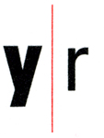
Laura Letinsky: Ill Form & Void Full
September 6 – October 20, 2012
Reception for the artist, Thursday, September 6, 6-8pm

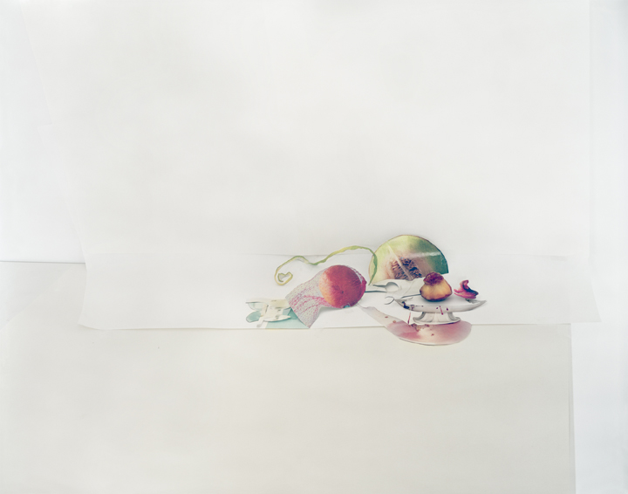
Yancey Richardson Gallery is pleased to present Ill Form & Void Full, an exhibition of new photographs by Laura Letinsky. In this new series of still lifes, a genre that has occupied her for 15 years, Letinsky reflects on the temporality of the still life, the self-referentiality of the photographic medium and the mutability of perception. By combining images from her own photographs and those culled from magazines with actual objects, she dissolves the difference between what is real and what is mediated, and between what is flat and what is dimensional. In addition, by using white as a color, the edges of paper as lines, and shadows as planes, Letinsky upends the viewer’s sense of space and perspective.

The arrangements in Ill Form & Void Full employ two-dimensional elements as sculptural objects, to dizzying effect. Collaged cutouts of food and tableware are pinned, taped or glued onto reproductions of table surfaces or white paper, all of which are placed on the studio wall and actual tabletops, creating a multiplicity of facades that collapse perspective and float in an indecipherable space of light and shadow.

In Untitled #3 (above), reproductions of an orange in a net and a slice of honeydew are placed next to the reproduced image of a platter, on top of which is set an actual half-eaten peach. A reproduction of a curling melon rind and mysterious, flattened swaths of color mingle with these objects. The whole arrangement is set on a white paper, atop a table against the studio wall. The juxtaposition of three-dimensional objects alongside their reproductions conceptually defuses the temporal urgency associated with vanitas. The tension here is rather the play between real and illusory space, and the puzzling implication of dimensionality on a flattened picture plane.

Rooted in the Dutch-Flemish vanitas tradition, Letinsky’s arrangements address the notion of time and the relationship between ripeness and decay; however, they do so by questioning notions of photographic authenticity, and the medium’s capacity to illustrate temporality vis-à-vis form, material, and narrative. As Letinsky states, “My photographs are very much about this medium, its self referentiality…I want an acute tension between what is in the picture – the image, what is name-able – and its status as an object.”

Born in Canada in 1962, Laura Letinsky received her MFA from Yale University in 1991, and was awarded a John Simon Guggenheim Fellowship in 2000. Ill Form and Void Full was presented as a solo exhibition at the Museum of Contemporary Art, Chicago in Winter 2012, and a mid-career retrospective will open at the Denver Art Museum in October 2012. Letinsky’s work is held in the collections of the San Francisco Museum of Modern Art, The Art Institute of Chicago, Museum of Fine Arts, Houston, Amon Carter Museum, Museum of Contemporary Art, Chicago, Museum of Contemporary Photography, Chicago, and the Stuttgart Museum, Germany, among others. Letinsky’s work has been the subject of three monographs: Venus Inferred (University of Chicago Press), Hardly More than Ever (Renaissance Society), and After All (Grafiche Damiani).

For visuals, please contact Walker Waugh at wwaugh@yanceyrichardson.com.
